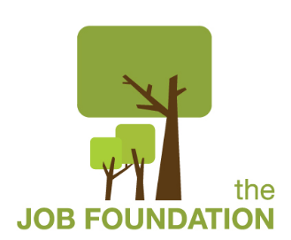 **Director of Development**

**Job Description**

**Title:** Director of Development

**Type:** Full-time, Salaried

**Supervised by:** Executive Director

**Supervises:** Volunteers, and Interns

**Position Summary:** The Director of Development is responsible for planning, organizing, and directing The Job Foundation’s fundraising, including individual and corporate donations, and grant writing.

**Responsibilities**

* Develop and execute The Job Foundation’s annual fundraising plan
* Secure financial support from individuals, foundations, corporations, and service organizations.
* Manage data entry/gift processing of all donations
* Maintain and update donor information in database
* Serve as the primary staff liaison to the Development Committee
* Collaborate with and report fundraising progress regularly to Executive Director, the Development Committee and Board of Directors
* Collaborate with Executive Director to develop and maintain ongoing relationships with major donors
* Create and execute a strategy for a large, sustained base of annual individual donors.
* Develop and track grant proposals and reports for all foundation and corporate fundraising
* In collaboration with Program staff, coordinate the organizations social media sites
* In collaboration with IT and Program staff, maintain website and develop content.
* Design or work with designers on development-related print materials.
* Oversee organization of fundraising special events when applicable
* Other duties as assigned by the Executive Director

**Qualifications**

* Minimum of a Bachelor's degree or equivalent experience
* One year of nonprofit development experience
* Solid, hands-on, budget management skills, including budget preparation, analysis, decision making and reporting
* Strong organizational skills, including planning, delegating, program development and task facilitation
* Knowledge of fundraising strategies and donor relations unique to nonprofit sector
* Skills to collaborate with and motivate board members and other volunteers
* Strong written and oral communication skills
* Ability to interface and engage diverse volunteer and donor groups
* Demonstrated ability collaborate with staff and volunteers
* Strong public speaking ability
* Car ownership and valid driver’s license is required
* Must pass a comprehensive background check

Updated 9/26/23